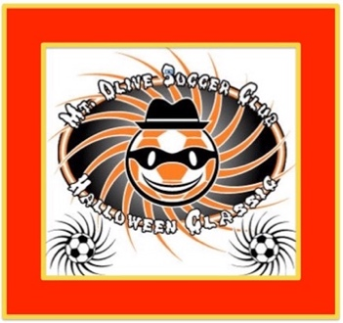

Coaches and Team Managers – October 29th Teams Only,
Welcome to the 23rd Annual Mount Olive Halloween Classic Tournament. Electronic Check In is our preferred method of check in this year. We are requesting that all teams check in electronically if possible. So that we’ll have enough time to review and approve submissions, all electronic check in must be sent in prior to Tuesday, October 25th at 9:00PM. We will make no exceptions…if you are doing electronic check in and we do not receive by 9:00 on Tuesday night, you will be required to come to in person check in at least one hour prior to your first game at our headquarters at Turkey Brook Park ONLY. We are not equipped to handle a large number of in person check in, so to avoid lines, please use our Electronic Check in option. If for some reason you cannot do electronic check in, you must reply to this email to let us know prior to the online check in deadline.
Electronic Check in Instructions
Please fill out the form below and provide the required paperwork in one pdf file, not multiple pdf files. If you are unsure of how to create ONE pdf file, you can either cut and paste your info into PowerPoint or word then save as a pdf, OR to create a pdf, use a website like this one: www.pdfcombine.com to help you create all information in one pdf. There is also a phone app called Fast Scanner that will allow you to photograph the documents then it will walk you through turning those photo’s into one pdf file.
Following are the required documents and the order it should be put in the pdf: In the subject line of your email, you must include your Club Name, Team Name, Age group and Gender Example: Mount Olive Soccer Club – Spurs – U10 – Girls
- Fill out form below, and return this page with information below as the first page of the pdf
- USYSA or US Club approved roster. If you have players listed on the roster that are not playing, please cross their names out. If you have any guest players, please write them in on your roster and include their card and medical form. ALL cards need to be from one organization including guests (all NJYSA or All US Club – not mixed)
- In alphabetical order by last name – copy of the front of each card. If you are using USYSA Cards you must also copy the back of each player card. All cards must be in alphabetical order (cards will be checked at games as well). Coaches cards should be copied and included as well.
- Copy of each players medical release form,
Email all of the above in ONE PDF file to vpops@mountolivesoccer.com before 9:00PM on Tuesday, October 25th. Once we review, you will receive a fast pass email approving you for electronic check in. You MUST print and bring that fast pass approval email with you to the tournament as well as have all of the original documents (cards, medical forms, rosters) with you on Saturday. You may be asked to provide the documents if any issues or questions arise. Upon arrival on Saturday, bring your fast pass approval to the Check In area at your field site to get your Coaches Bag and information.
Team Name
Team Age
Team Gender
Contact Name
Contact Cell Phone
Contact Email
Comments

